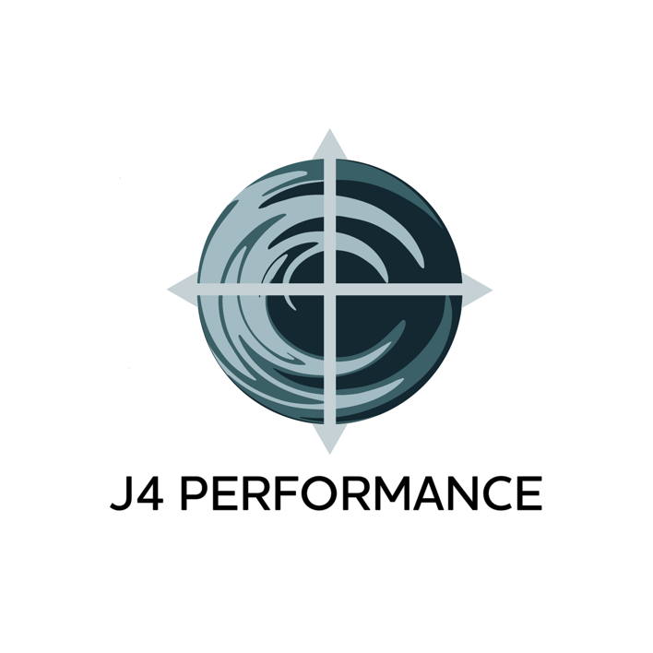
ONLINE TRAINING APPLICATION

Name:

Email:

Phone:

Which plan would you like to begin? (Please circle one)
- Live Zoom Training
  - 12 sessions
  - 24 sessions
- YouTube Remote Training+**
  - 2-day, 3-week program (6 sessions)
  - 3-day, 3-week program (9 sessions)
  - 4-day, 3-week program (12 sessions)
  - 5-day, 3-week program (15 sessions)
- YouTube Remote Training**
  - 2-day, 3-week program (6 sessions)
  - 3-day, 3-week program (9 sessions)
  - 4-day, 3-week program (12 sessions)
  - 5-day, 3-week program (15 sessions)

What are your goals? Please be specific.

How would achieving these goals impact the quality of your life?

Have you been training consistently for the last 3 months? Yes__ No__

If yes, please provide the program you have been following by emailing jimmy@j4performance.net

Have you ever had surgery before? Yes__ No__

If yes, please describe the surgery & if you still experience issues since surgery:

Do you have any chronic aches or pains? Yes__ No__

If yes, please describe symptoms that are persistent:

Are you on medication? Yes__ No__

If yes, which medications and what conditions are you being treated for?

If you have answered yes to 1 of the last 3 questions, does this impact your ability to work out? Yes__ No__

If yes, in what way?

What equipment do you specifically have access to for your training?
If you are working out at home, please list all equipment including weights of each piece of equipment

Do you feel confident in using all the equipment? Is there specific equipment that you enjoy using and some you do not? Please describe.

How much time do you have available to train? Can you be on a consistent schedule? Please describe what that schedule would look like:

What is your main concern in being successful?

By signing below, you understand that it will take a minimum of 3 months of consistent training to achieve significant results and understand that this is why you are committing to a 3- or 6-month program.

Name: Date:

Signature:

